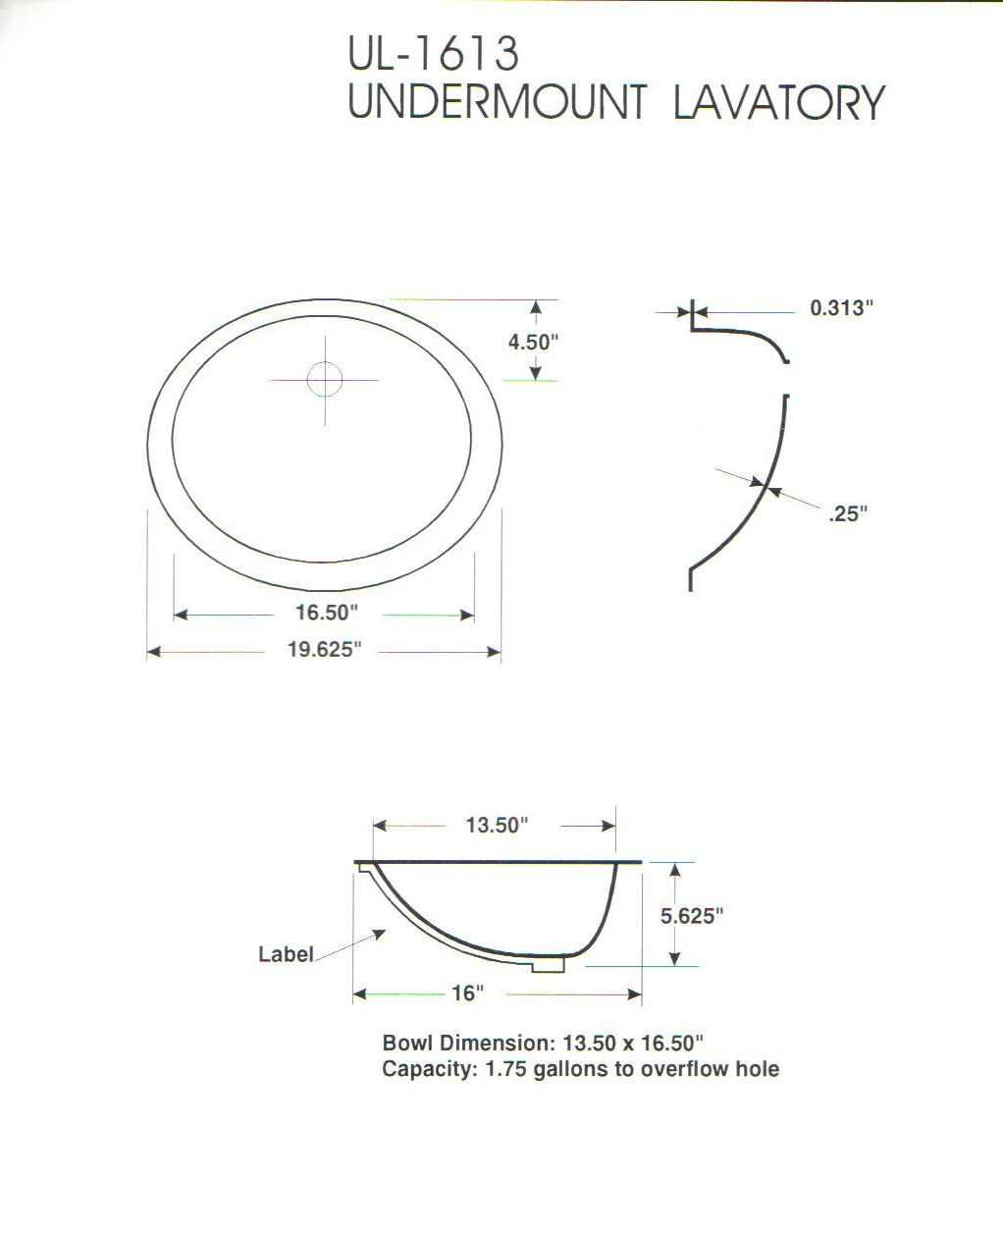

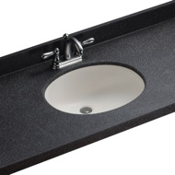
418mm

465mm
120mm
10mm
10mm
328mm
465mm
145mm
Capacity 8 litres to overflow hole
BS-110

Loose overflow supplied without hole predrilled

