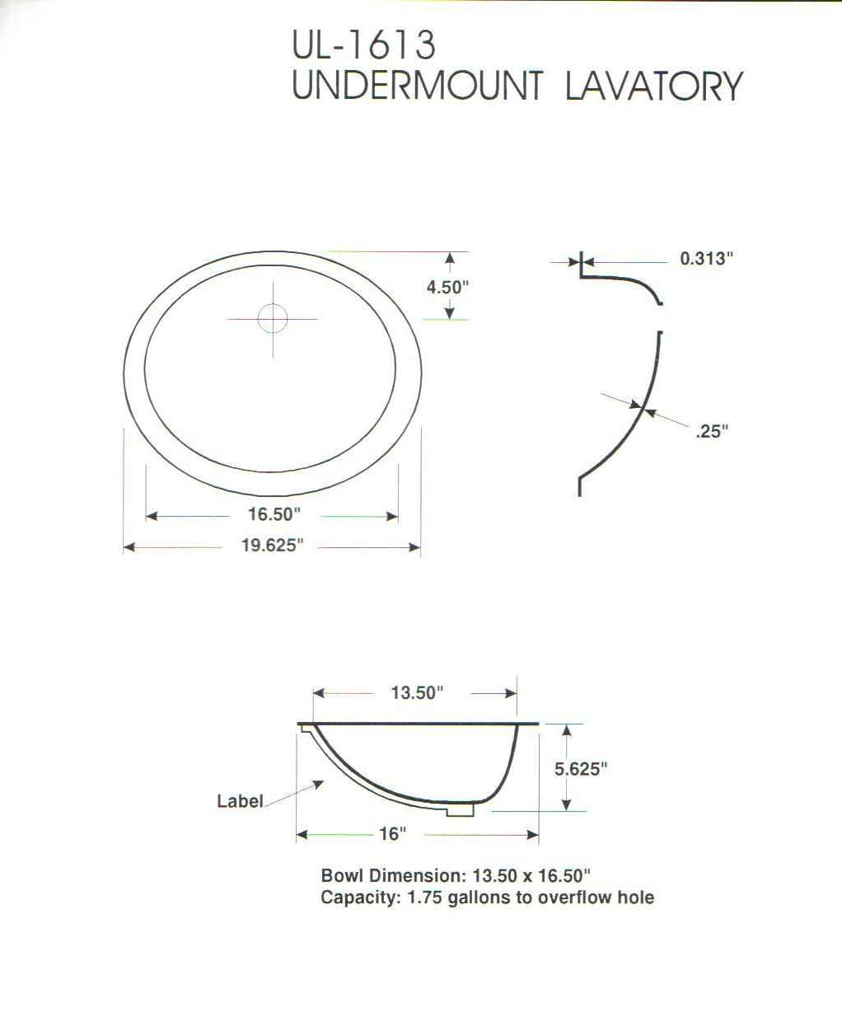

520mm

566mm
80mm
10mm
10mm
364mm
412mm
163mm
Capacity 10 litres to overflow hole
BS-115

Loose overflow supplied without hole predrilled
