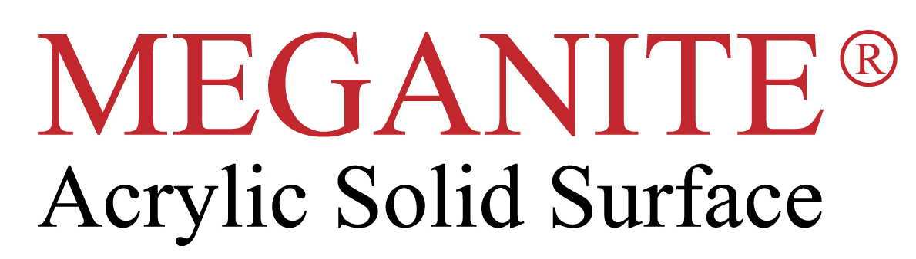
RECOMMENDED CLEANING PROCEDURES FOR
MEGANITE SOLID SURFACE TOPS

- CLEAN ALL EVERYDAY SUBSTANCES OFF IMMEDIATELY WITH A CLOTH AND SOAPY WATER. IF STAIN HAS DRIED IT MAY NEED ABRASIVE CLEANER SUCH AS JIF, CIF. ALSO, CLEANERS WITH 5% BLEACH CONTENT ARE VERY GOOD TO KEEP WHITE SURFACES LOOKING PRISTINE.

- REMOVE HARSH CHEMICALS AND HEAVY BIRO MARKS USING A SPONGE AND BAR KEEPERS FRIEND, SCOURING PAD SIDE OF SPONGE MAY BE REQUIRED.

- SCRATCHES IN THE SURFACE CAN BE REMOVED USING COURSE AND THEN FINE WET AND DRY SANDPAPER.: 320/600 GRIT AND SCOTCHBRITE OR SUPER G PAD. FINISH EACH GRADE WITH FAST CIRCULAR MOTION. DARK COLOURS SHOULD BE GIVEN A FINAL FINISH WITH SOLID SURFACE POLISH; SPRAY POLISH AND WIPE OVER WHOLE AREA, LEAVE WET FOR 10 MINS AND HAND BUFF THE SURFACE WITH A DRY CLOTH.

- CIGARETTE BURNS CAN BE REMOVED WITH BAR KEEPERS FRIEND. HEAVY BURN MARKS MAY REQUIRE SCOURING PAD OR EVEN FINE WET AND DRY.

- TO KEEP YOUR SURFACE LOOKING SHINY AND STAIN FREE WE RECOMMEND REGULAR CLEANING USING ANTI-STATIC GLASS CLEANER OR SOLID SURFACE POLISH, AVAILABLE FROM THE INSTALLER/RETAILER.

- TO KEEP YOUR SINK LOOKING LIKE NEW OCCASSIONALY FILL 50/50 BLEACH AND WATER FOR 15 MINUTES AND THEN RINSE OFF.

- TO PREVENT DAMAGE TO THE SURFACE, DO NOT CHOP OR CUT DIRECTLY ON THE AVONITE, USE A CHOPPING BOARD. NEVER PUT A HOT PAN/POT ON THE SURFACE , USE A TRIVET OR HEAT PAD . ON DARK COLOURS MORE CARE WILL BE NEEDED TO PREVENT SCRATCHES FROM APPEARING, USE MATS UNDER CERAMIC WARE AND AVOID DRAGGING ITEMS ACROSS THE SURFACE. ALWAYS RUN COLD WATER TAP WHEN TIPPING BOILING WATER FROM PANS INTO YOUR MEGANITE SINK.

** (ALL THE ABOVE CLEANING ITEMS CAN BE OBTAINED FROM ANY MAJOR
LOCAL SUPERMARKETS)

