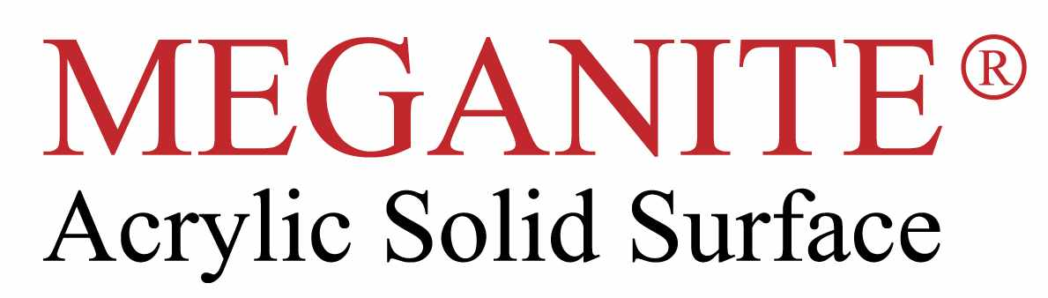

CUSTOM COLOUR , CUSTOM SIZE PROGRAM:

Meganite already has a library of 700 decors already matched to the solid surface brands in their lab ready for production.

They can make any custom colour , from solids from NCS, RAL reference to granites from a sample supplied , a match will be made for approval in 2weeks.

Min order for custom colour 30 sheets (3660x762x12mm )

Meganite can produce custom size sheets to save money on projects by reducing wastage factor and fabrication time .

Custom width any size from 600mm to a max of 1500mm

Custom length any size from 2400m to a max of 3660mm

Custom thickness any thickness 6mm to a max of 30mm

Min order for custom size 20 sheets , if combined with custom colour min of 30 sheets.

