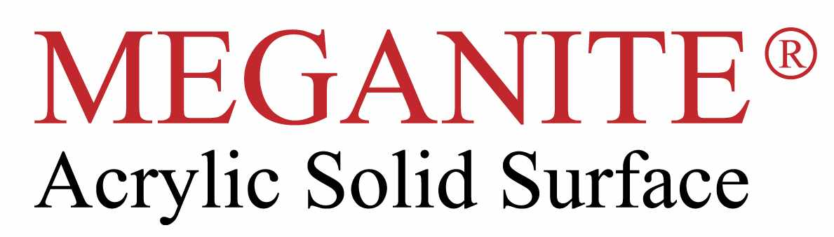

Technical Bulletin – Autumn 2012

This bulletin refers to the Meganite colours contained in the Pearl collection of colours , specifically :

414 Dancing with the Stars 418 See Glass
416 Beyond The Sea 419 Surfin Safari

These Decors contain natural materials that create an iridescent dimensional appearance which is exclusive to the Meganite brand, in particular large flakes of mother of pearl , giving a unique natural appearance.

Please note that mother of pearl is a harder substance than acrylic resin , as a result the large flakes can be felt slightly above the sheet surface from the factory finish due to the through sanding system.
Normal fabrication tooling and techniques should be used with these colours , following these guidelines .

Use sharp TCT router cutters when machining profiles to avoid any chip breakout, any small voids can be easily filled with the colour match joint adhesive .

To achieve a flat , uniform finish on the surface the following guideline should be followed :
Use a hard base pad on the orbital sander (not medium or soft grade).
Use 3M Micron TM sanding discs to achieve a flat finish using the following grades
160 Micron
100 Micron
60 Micron (matt finish)
30 Micron (satin Finish)
The equivalent grades can also be used with 3M Trizact TM sanding discs.
Both of these products are specifically designed for sanding plastics etc and work with the mother of pearl.
Please allow additional finishing time with these Pearl decors.

Please note thermoforming is limited due to the large natural particulates in these decors .

