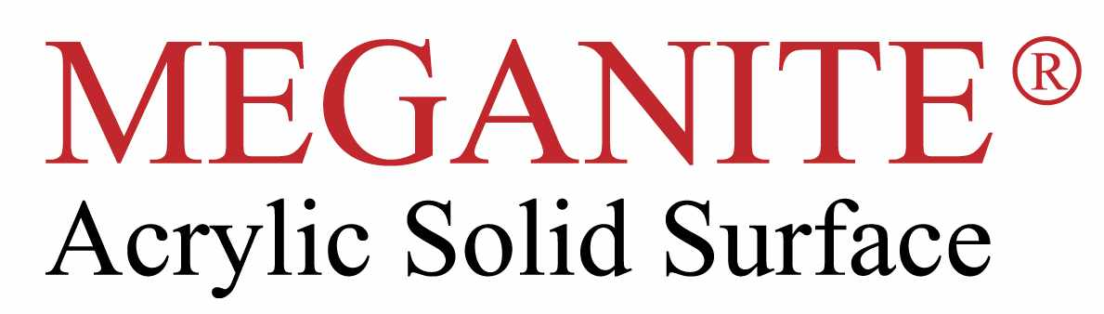

Declaration Of Conformity

We hereby confirm that the Meganite Product produced by Meganite Inc has been tested to meet standards for quality , health , safety and environmental protection requirements.

Meganite has the following certification :

ISO9001
Greenguard air quality
Greengaurd Gold award children/school surfaces
Reach EU, SGS raw material testing
European commercial food zone use

All the above certification conforms to the directives of CE marking conformity.

